Name:_________________________________
Photoshop Masking Nameplate

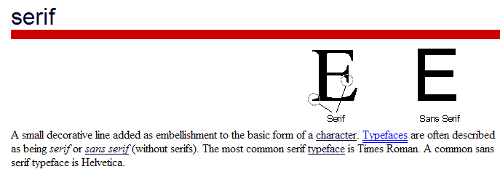
What you need to do:
- Create a NEW Photoshop canvas dimensions 10” x 4”inches
  - Make sure background contents is set to WHITE and Color Mode is set to RGB 300 resolution
  - Save to a Photoshop folder name the file Last Name First Initial Masking Name
- Pick a SERIF FONT and type your name as big as you can make fit! (If you name is not a least 6 characters long use your last name?, middle?, nickname?). Add an effect to the text and change the color.
- Choose a THEME (animals, food, flowers, anything you like)
  - Search for usable pictures online; be sure they are good quality! And, they all need to be the same type of graphic—either all cartoons or all photographs or all clipartish stuff… not a variety).
  - Save all the pictures to your picture folder—you must use at least 10—the more the better….
- Open the pictures in Photoshop, using the various techniques covered so far in class, move the individual images over to the canvas with your typed name—LIMIT YOUR AMOUNT OF ERASER! Try to use magnetic lasso, defringe etc. (refine edge before you move it over!)
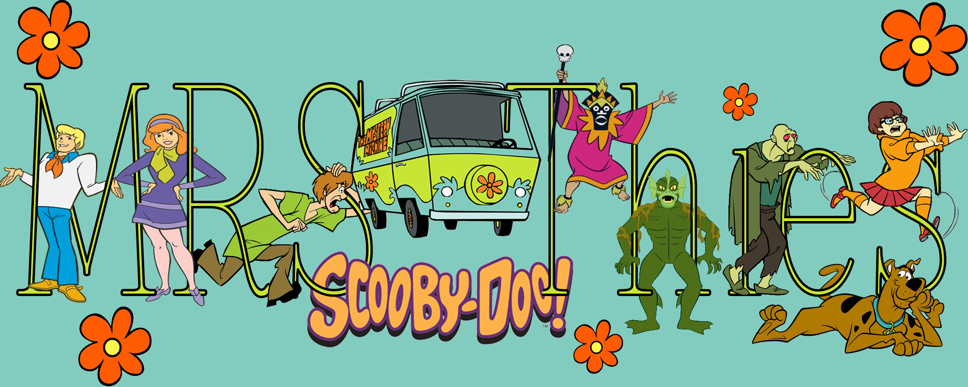
- Place your pictures/graphics on top of your typed name. Duplicate the layer and put one below. The one on top gets a mask.
You are creating a layered object.
  - Each of your pictures/graphics should ‘wrap around the letters. Part in front, part behind
  - Remember, the goal is to create an original and creative Typography Font Art. Your name should be covered with pictures/graphics, but should still be recognizable!
  - Save when you are done…

- Print the image to color printer cut and paste on construction paper then have cut down also to size—paperclip to this rubric

- Save your File Photoshop folder into the Handin Folder.

Criteria | Points | Earned
Canvas Size 10” wide-4” tall 300 resolution change background | 5
Name typed with a font that has serifs (the more the merrier!) Large enough, Add a layer effect (example stroke, bevel emboss)and Color changed. | 10
Easily identifiable THEME | 5
High Quality pictures/graphics well cut out and placed minimum of 10. | 20
Graphics in the back and front wrapped cleanly—Makes sense…does not go through a letter but wraps around. At least 10 Wrapped! | 10
Name still recognizable | 5
Saved as Photoshop document (PSD) Screen check layers named and put into folders…(example: Masked, not masked)  This rubric attached by student—printed out correctly and mounted. | 10
Creativity and Time spent and all directions followed | 10
Total Points | 75

